REGIONAL FORUM ON SUSTAINABLE DEVELOPMENT for the UNECE REGION
Geneva & online

Involvement of the Civil Sector in the SDGs Implementation in the Czech Republic and Sharing Experience with SDGs Awards

SIDE EVENT of the Czech Republic
April 6, 2022
8:30 - 9:45

A moderated discussion will focus on:
• Sharing experience with the involvement of the civil sector in the Sustainable Development Goals (SDGs) implementation in the Czech Republic from the government´s point of view
• System of SDGs Awards in the Czech Republic
• Sharing experience with the SDGs implementation in the Czech Republic from the perspective of Czech companies

Target audience:
Government and international organization officers, representatives of civil society organizations.

AGENDA:
8:30 - 8:40 Opening and introduction
Alexandr Sporys - Ministry of Foreign Affairs of the CR, Department of Multilateral Economic Relations, Director
Jitka Brodska - Permanent Mission of the CR to the UN Office in Geneva, Deputy Head of Mission

8:40 - 8:50 Involvement of the civil sector in the SDGs implementation in the Czech Republic
Anna Paskova - Ministry of the Environment of the CR, Department of Environmental Policy and Sustainable Development, Director

8:50 - 9:00 Questions and answers

9:00 - 9:10 Success story of SDGs awards in the Czech Republic
Lucie Madlova - Association of Social Responsibility, Founder and Executive Director

9:10 - 9:20 Role of a global technology company in the SDGs implementation in the Czech Republic
Petr Smid - Google Czech Republic, Country Marketing Manager CZ/SK, HU, RO

9:20 - 9:30 Role of the civic tech organization in accelerating non-profit projects with an impact on SDGs
Eva Pavlikova - Cesko.digital, Co-founder & CEO

9:30 - 9:40 Questions and answers

9:40 - 9:45 Closing remarks
Alexandr Sporys - Ministry of Foreign Affairs of the CR, Department of Multilateral Economic Relations, Director

The event will be moderated by Mr. Alexandr Sporys and Ms. Lucie Madlova.
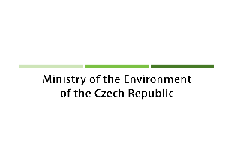
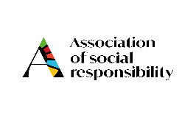
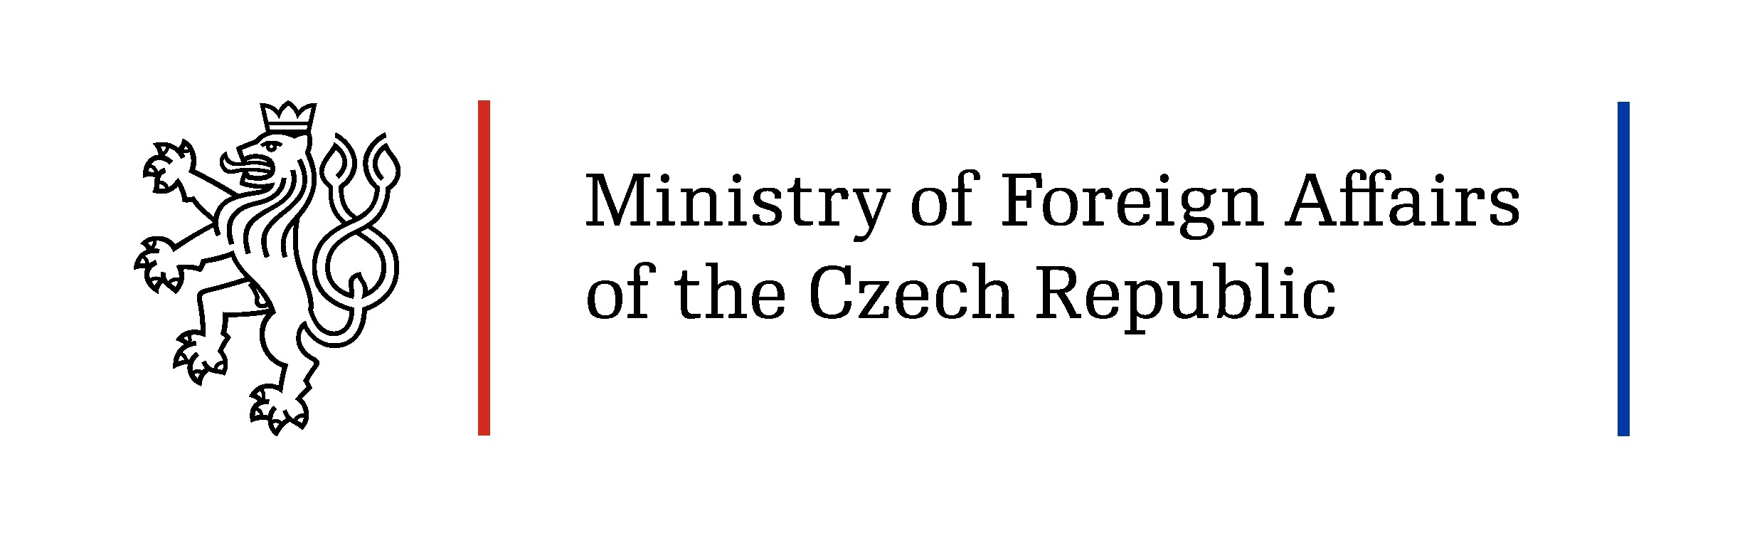

Ministry of Foreign Affairs of the Czech Republic places special emphasis on SDG 16 (Sustainable Development Goal) - Peace, justice and strong institutions. In the spirit of the tradition of supporting human rights and democracy, we remain a stronger supporter of the SDG 16 implementation at the global and EU levels. We perceive SDG 16 as essential for the implementation of a number of other SDGs. The support for SDG 16 is based both on the long-term priorities of the Czech Republic´s foreign policy and the Strategic Framework of the Czech Republic 2030.

Ministry of the Environment of the Czech Republic will focus on the collaboration of the state administration with the civil sector in the SDG implementation since 2015. It will summarize all kinds of NGO´s involvement in the SDGs implementation and reflect on the experience and lessons learned - before, during, and after Covid-19 crises. Despite the broad scope of the activities of the civil society, the main challenge poses the proper communication linking the particular projects and activities with the global goals. We will be sharing our experience with the involvement of the civil society in the SDG´s implementation in the Czech Republic. It will honestly reflect and formulate lessons learned in this regard.

Association of Social Responsibility (ASR) is a pioneer in promoting SDGs in the Czech Republic. ASR is the largest initiative for social responsibility and SDGs. The SDGs Awards have been presented in the Czech Republic since 2017 as the first ever awards for the implementation of the Sustainable Development Goals in the world. The SDGs Awards themselves embody collaboration and partnership between non-profit organisations, government and the private sector (public-private partnerships), thus fulfilling the essence of SDG 17. Inspirational examples of award-winning projects will be presented with the aim of inspiring other countries to strengthen cooperation between the non-governmental sector and government in the implementation of SDGs.

Google perceives digitization and application of advanced technology as a key catalyst for economic growth and sustainable development. However, the skill set of today's population is not well set up to support the digital transformation. Developing a wide-ranging re-skilling strategy, updating youth education for the future and promoting lifelong learning and mid-career training is necessary to build a skill set for the future. Google focuses on contributing to lifelong learning and mid-career training - especially the development of digital and entrepreneurial skills - under the umbrella of Grow with Google program. The program has already impacted over 10M people in Europe, the Middle East and Africa and we develop it further, in partnership with local institutions throughout the region.

Cesko.Digital and the global network of civic-tech organizations aims at bringing novel approaches to citizen engagement, peer-to-peer networks and collaborative partnership across citizens, communities, non-profit and government organizations. We try to enable civil society to implement SDGs by creating digital platforms that are innovative, ethical, and inclusive. Cesko.digital mission got accelerated by Covid19, bringing an urgent need for massive action to mitigate the pandemic’s effects, for society’s most vulnerable parts (with a critical area being education). Through our flagship project “Ucime online”, we connected teachers, volunteers, NGOs, etc. to help 2 920 families, 618 schools, and 10 000 teachers.

The event will be held in English.

REGISTER HERE

