Final Report – Thank You Message and Photos of Activities
Project No. 11-20LA02
Project title: Inclusive, Child-friendly and Improve Quality Learning Outcomes of Pre- and Primary School Environments in Lao PDR

Message from students of Phaluang School
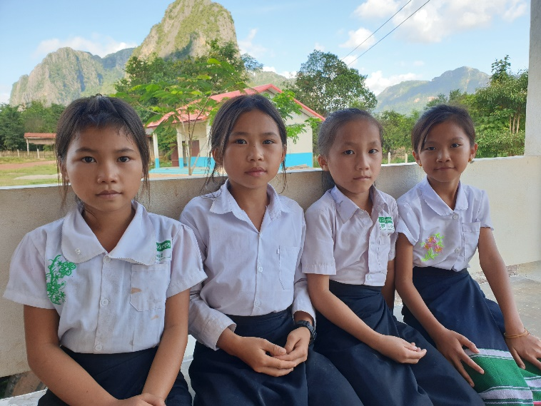
My name is Thodsai Chao, Malin Thor, Kue Her, and Yeer Her. We are studying at Grade 4 of Phaluang primary school. This school year is so special to us, we have many new things in our school namely: a library with reading books, new textbooks, LCD and screen projectors, ICT equipment, fans, electricity uses in the school, drinking water, place for wash hands and new buckets, new tables and benches and other items. We also participated in group activities such as hands and mouth wash - led by a local healthcare team, reading, drawing activities and playing games with the project team. We were very happy and had fun and learn from those activities.
We like to come to school every day and learn from our teachers. We also like to play games with friends when we meet at school. Our learning difficult subject is math because it have to calculate. For Lao language and world around us are easier subjects to us. In the future, we want to become a doctor because we will be able to support our families when they get sick.
We are very happy that we got the new things in our school this year particular. We will come to school regularly and take care of those given items. We thank you for supporting our school, and we hope that the project will continue to assist us improve our school next year.

Thank You Message from The Principal of Phaluang School
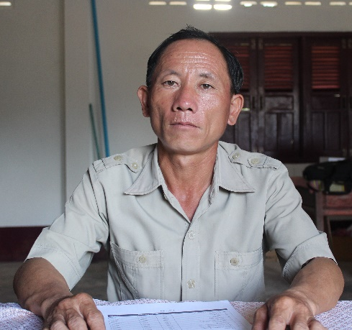
I am the principal of Phaluang Primary School, Fuang district, Vientiane province. On behalf of all village organizations, community members, teachers and students at Phaluang village, I would like to appreciate and care all of the project team to support a library, kitchen, education materials as necessary things to our school. All of these are massive value, which help to reduce expenses of poor communities and makes them to believe in the education. It shows that they send their children to enroll in school as appropriate ages. In addition, it makes our children who are living in rural area and lack of opportunities can access to school with good facilities like the children in city.
I praise all of the supports have been providing to our school and students. I promise to the organization that I will engage all teachers and students to use the materials for the most of its value. We will take care, use, and keep the materials in good conditions, as the organization recommended.
Finally, I wish all of you, AEA Laos and all supporters, forever healthy, and successful in your works and duties. I believe that you will always support the necessary for our school.
Thankful,
Phaluang Primary School Principal

Photos of activities
- Library room handed over
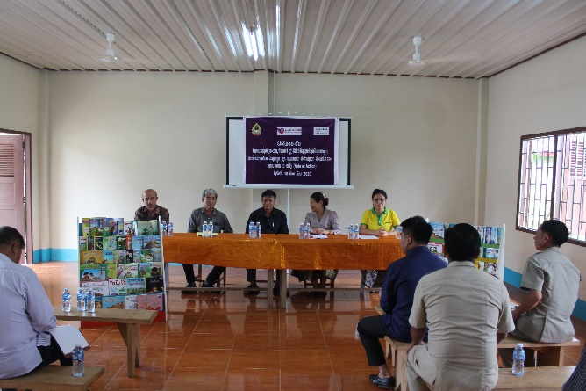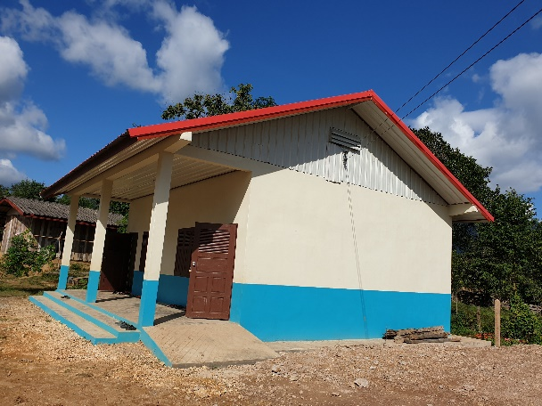
- Tables and benches
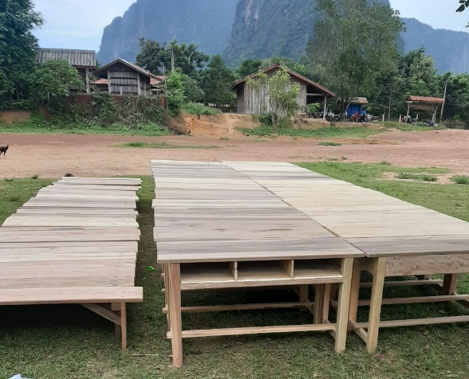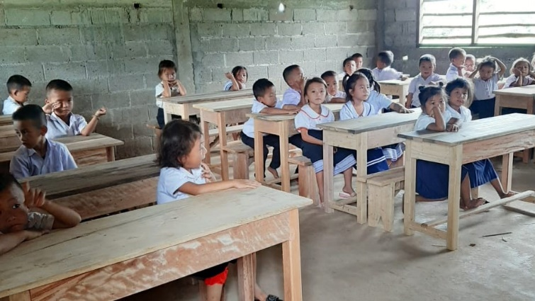

- Hygiene campaign
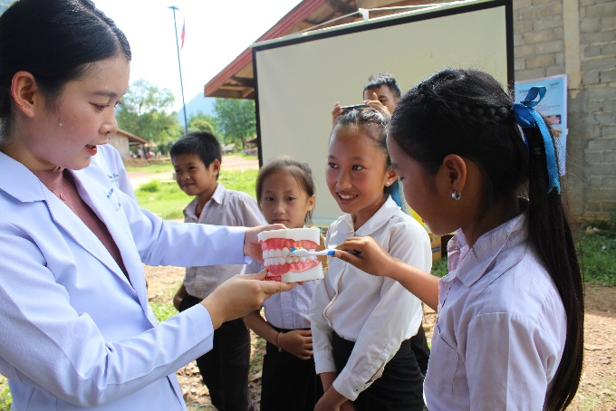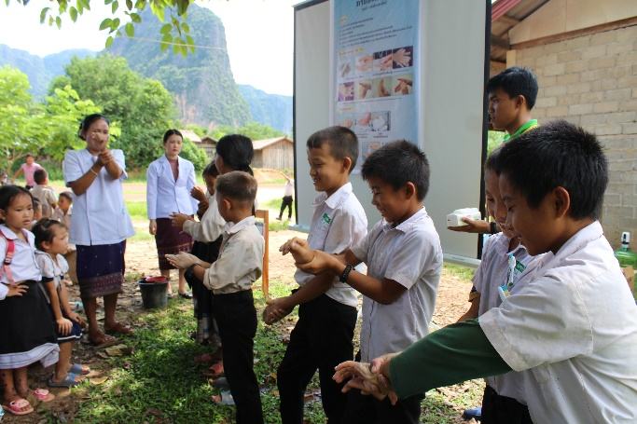
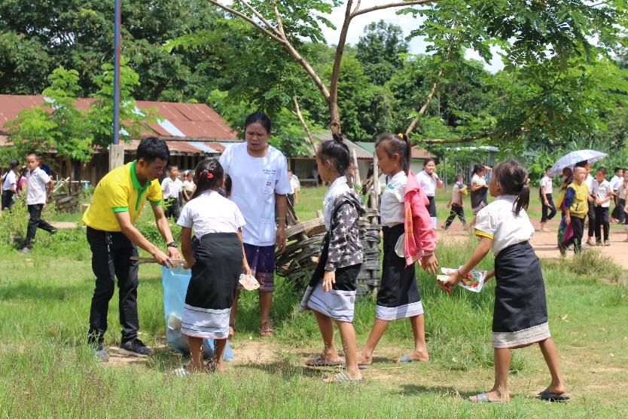
- Children help laid pipes for handwashing stations
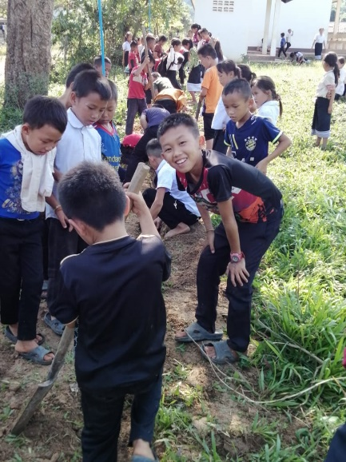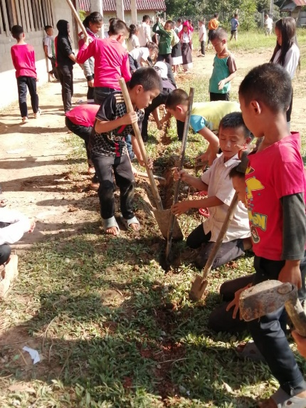

- Water filter installation in schools and bookshelves
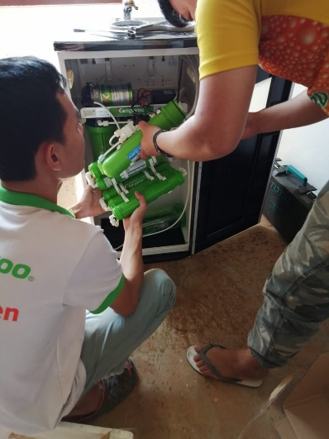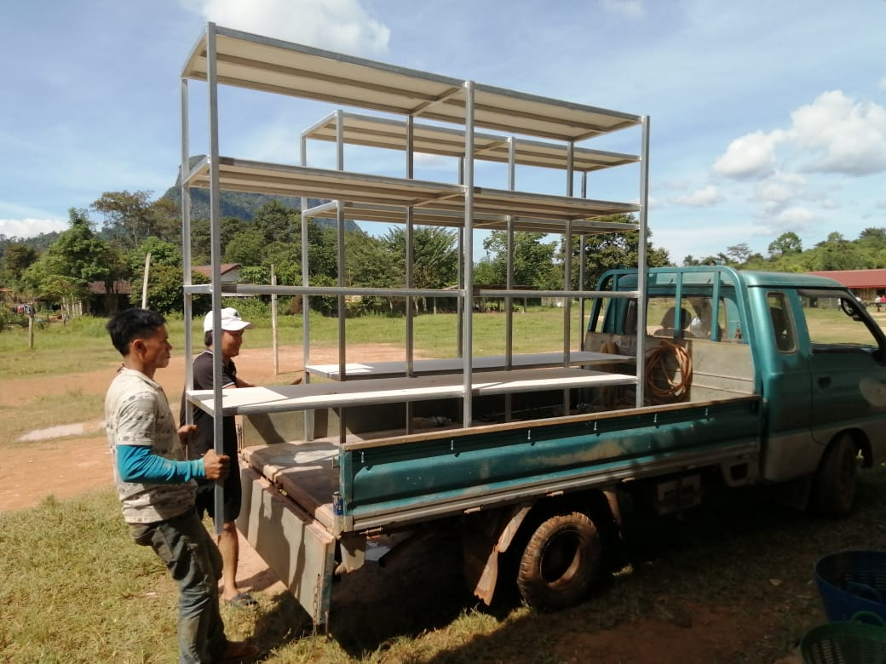
Electical Installation and Libraryroom with Computer and LCD Projector Usage
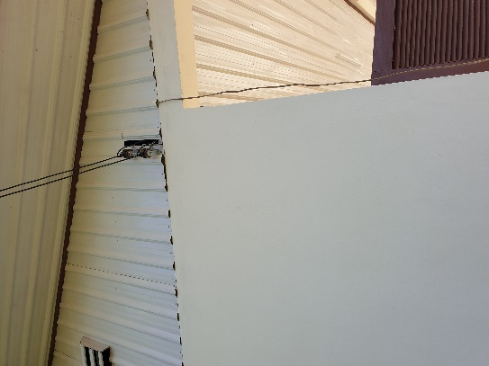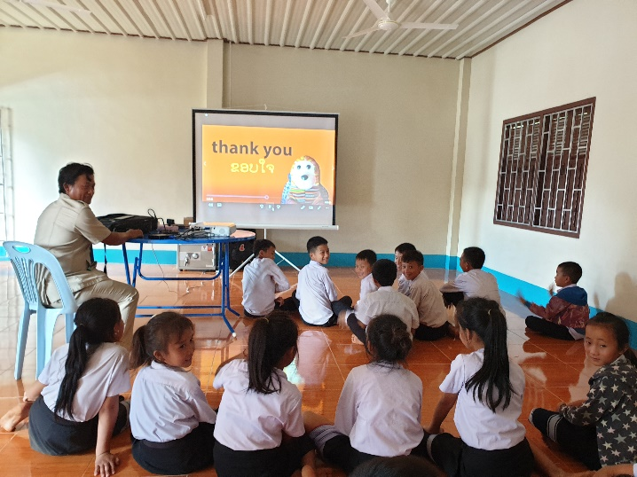
New Black/Green Board and New TextBooks and Reading Books
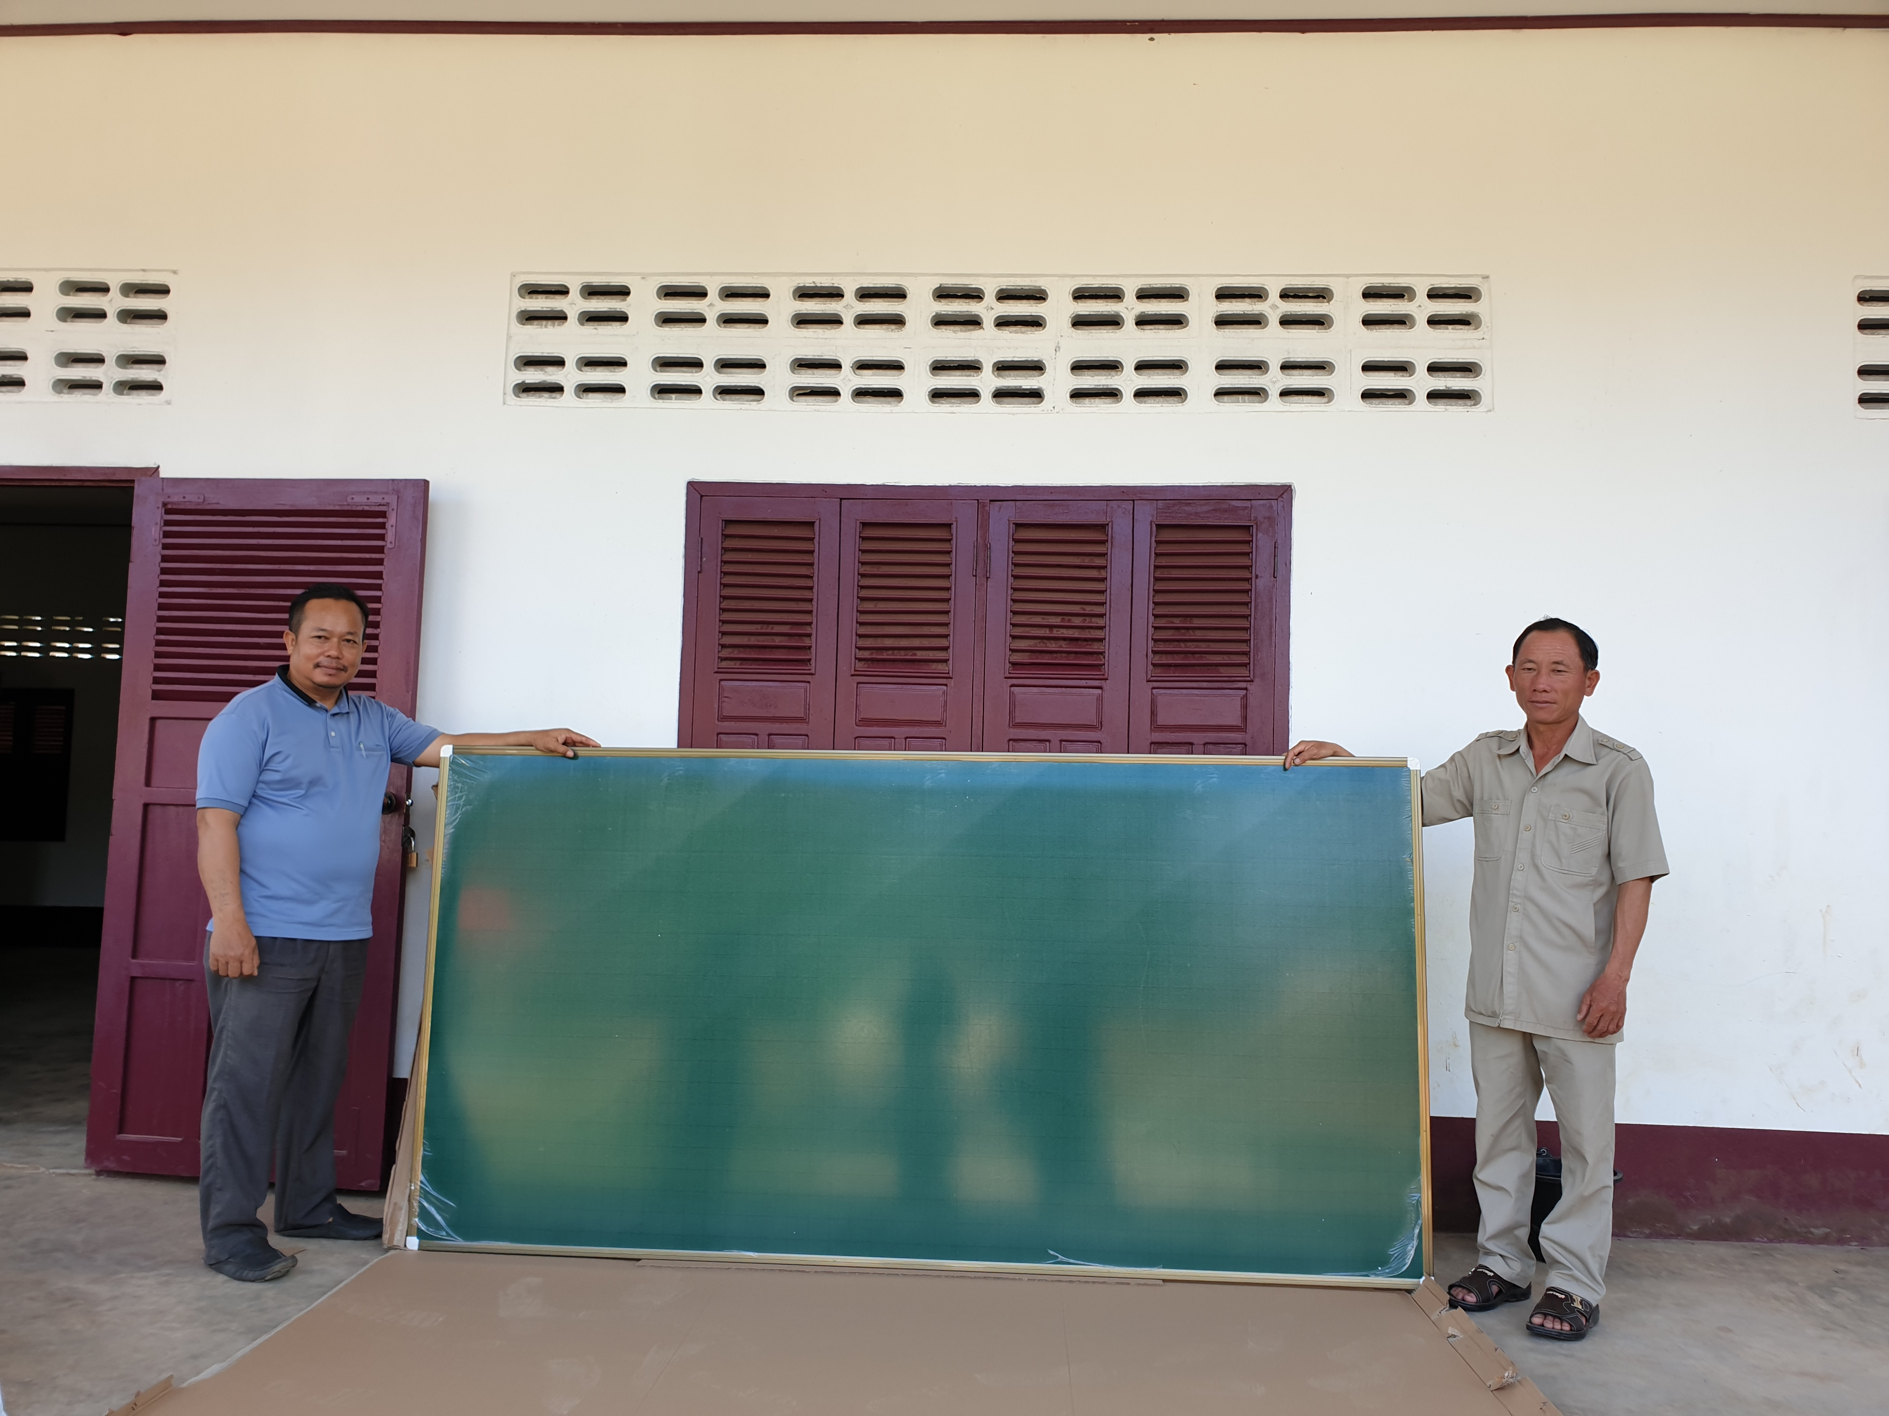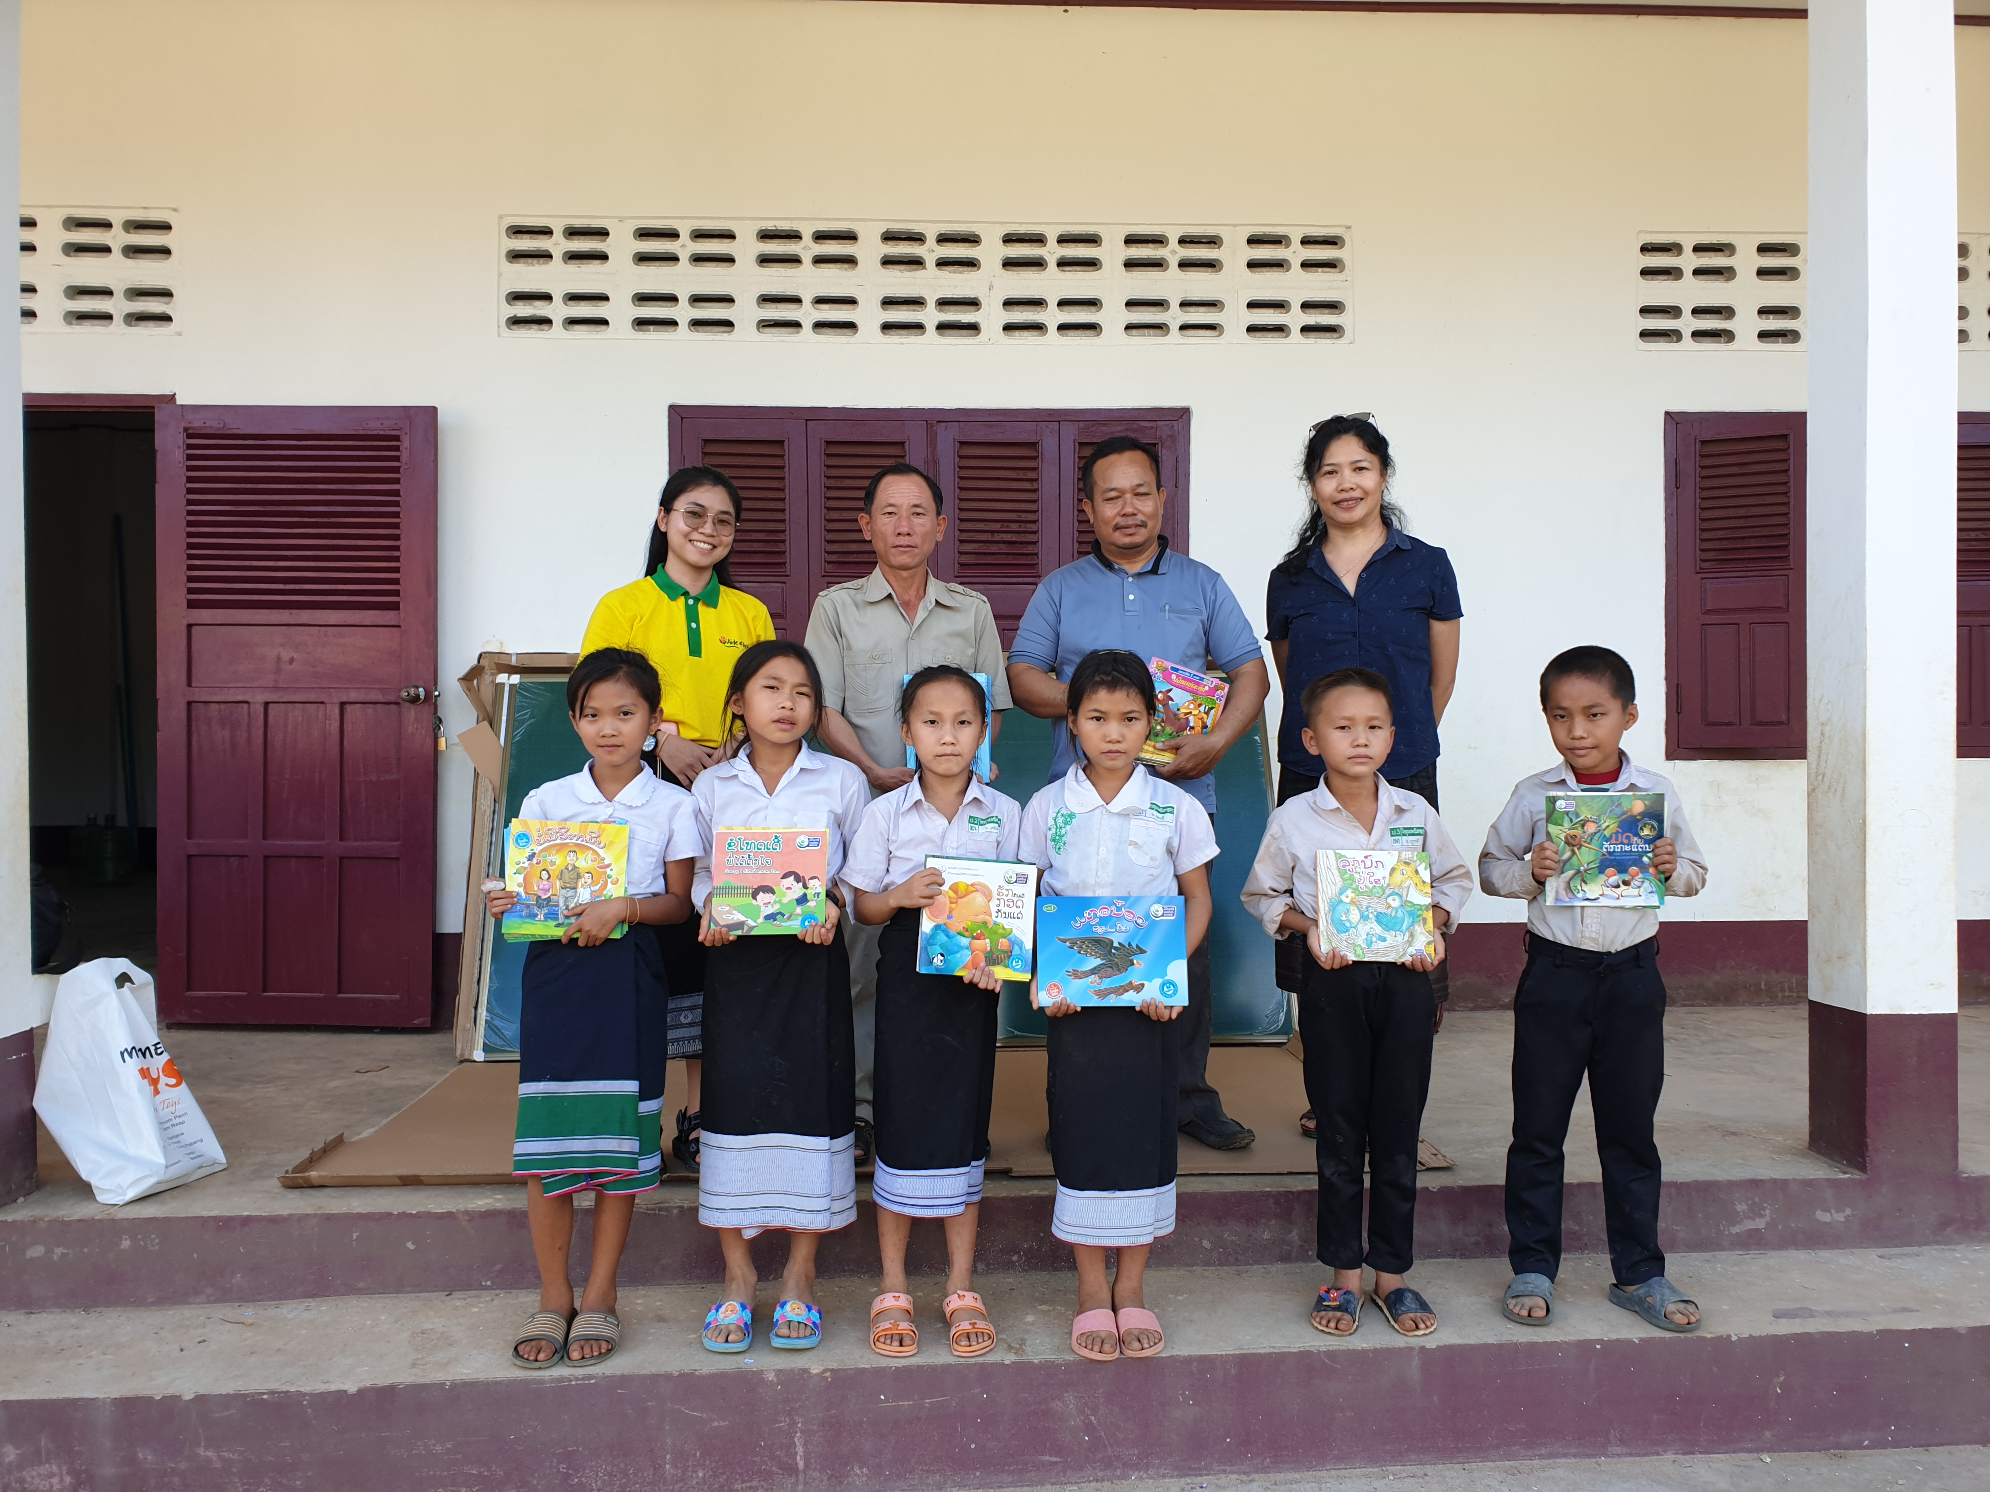
Water Filters and Drink Water Bottles
